**STOCK MARKET ANALYSIS**

The data used in this paper if from the stock market (finance.yahoo), including PG, AMZN, AAPL and F for the period from 01/01/2020 to 31/05/2022. We will learn how to get stock information, visualize its various aspects, and finally we will look at a few ways to analyse the risk of a stock, based on its previous performance history. The Monte Carlo Simulation method was used to predict future stock prices.

**1. The change in price of the stock overtime:**

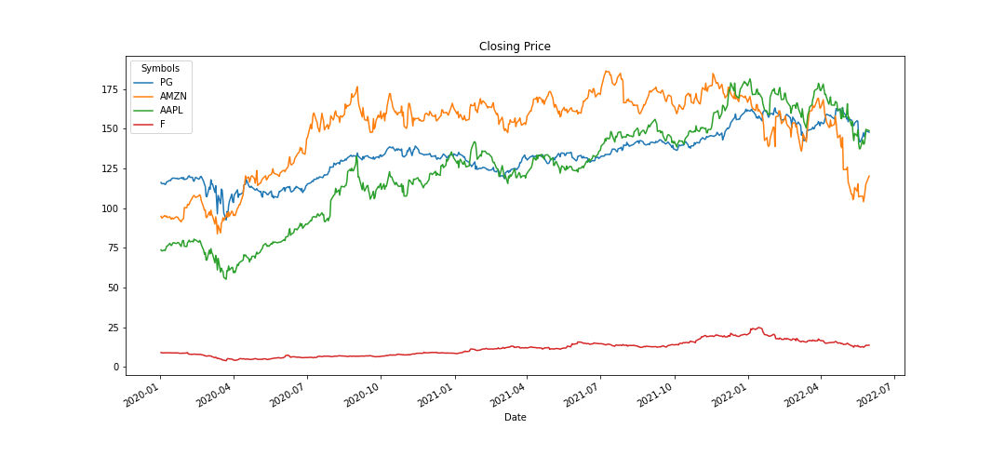

**Figure 1: Closing price from 01/01/2020 – 31/05/2022**

The figure 1 shows the trend of the closing prices of four companies for the period from 01/01/2020 to 31/05/2022. The prices of F were the lowest and pretty stable during the study time. Besides, the prices of AAPL and PG increased, from 73.7859 USD to 148.84 USD, 116.198 USD to 147.88 USD, respectively.

**2. Summary statistic of 4 companies:**

Table 1 presents our calculations on the statistic of each company.

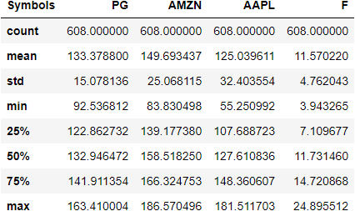

**Table 1: Summary statistic**

Looking at the detail, the standard deviation of AMZN was 25.068115 and AAPL was 32.403554. They were larger than PG (15.078136) and F (4.762043) that means there were a lot riskier with the stock of AMZN and AAPL than PG and F.

**3. Moving average of the stocks:**

The figures below show the moving average (MA) of the four companies in 10 days and 50 days.

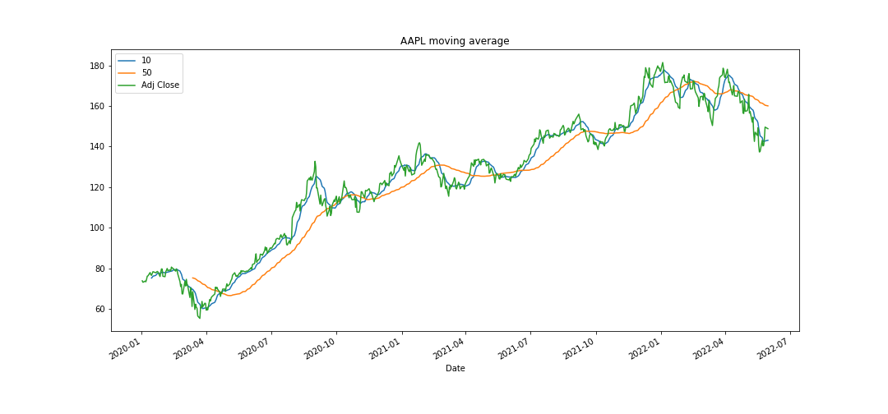

**Figure 2: Moving average of AAPL in 10 and 50 days**

Figure 2 indicates that most of time, the price of AAPL was above MAs and MA in 10 days stayed above MA in 50 days, therefore, there was an uptrend. It is said that we should buy stocks of AAPL.

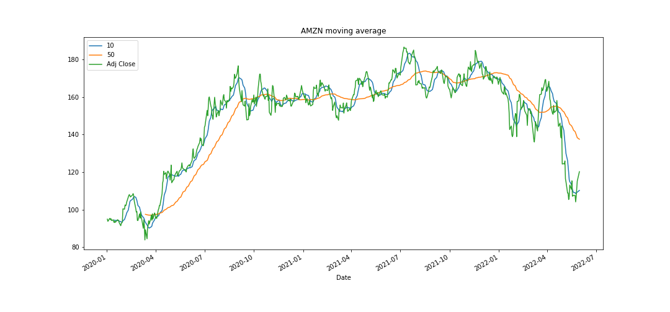

**Figure 3: Moving average of AMZN in 10 and 50 days**

However, for AMZN, the trend was unstable. For the period from 01/2020 to 10/2020, there was an uptrend. Then there was a downtrend at the end of the study time when price was belove Mas and MA in 10 days stayed below MA in 50 days.

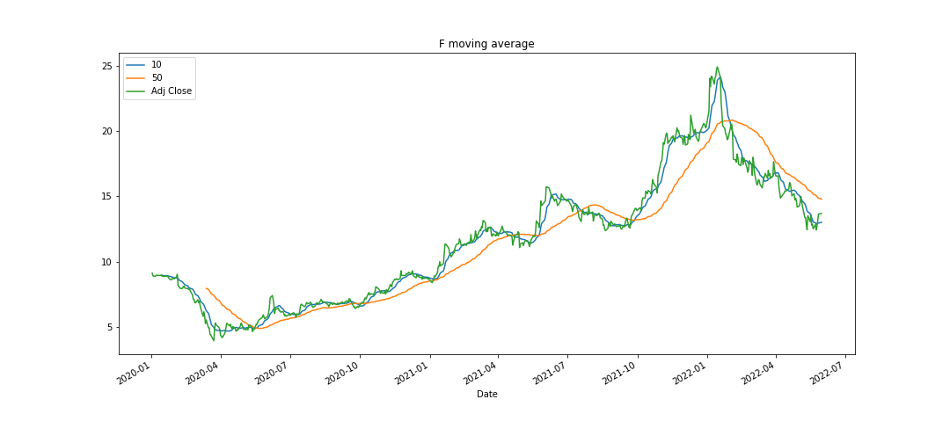

**Figure 4: Moving average of F in 10 and 50 days**

Figure 4 shows the uptrend of F for the period from 01/2020 to 01/2022. Then there was a downtrend for the first 5 months of 2022 when MA in 50 days was above price and MA in 10 days.

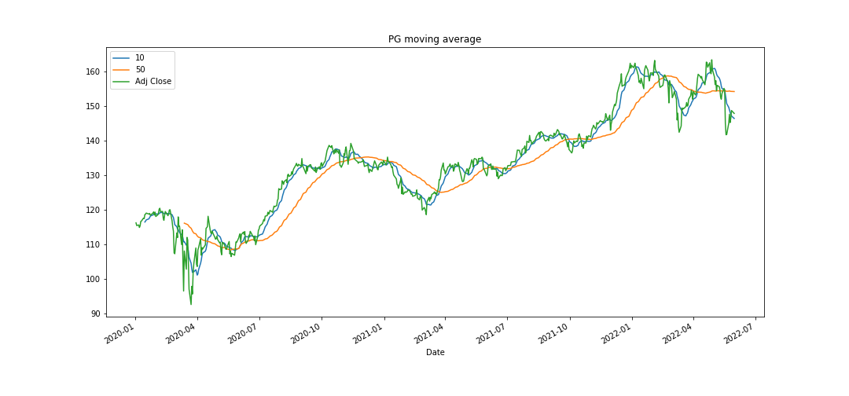

**Figure 5: Moving average of PG in 10 and 50 days**

In general, it is time to buy stock of PG cos there was an uptrend when MA in 10 days stayed about MA in 50 days and price was above MAs.

**4. Daily return of the stock:**

The daily returns of the stocks were presented by plot and histogram. As we can see from the figure 6, F and AMZN had higher positive and negative daily returns than PG and AAPL, hence F and AMZN were typically more risky than PG and AAPL, which create smaller swings in value.

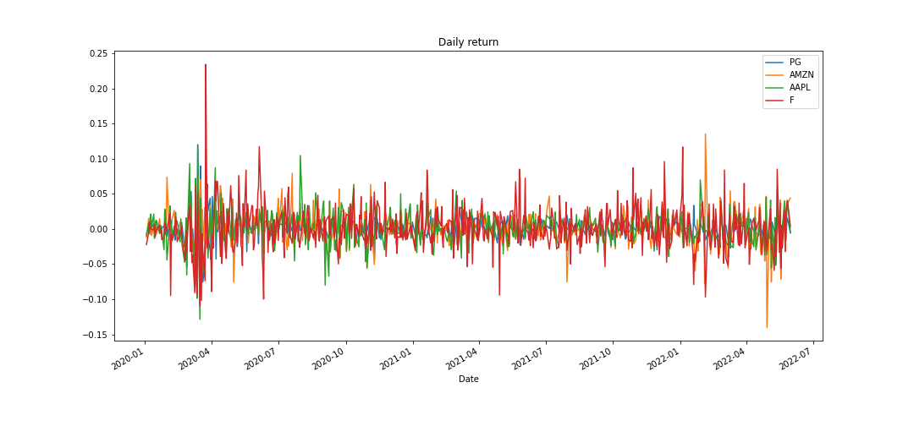

**Figure 6: Daily return of the stock**

**\*) Using histogram to get an overall look at the daily return:**

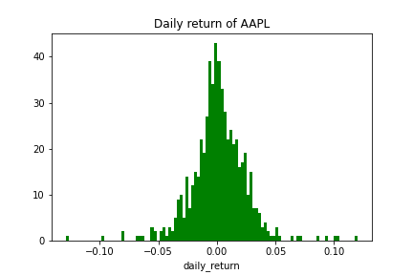

**Figure 7: Daily return of AAPL**

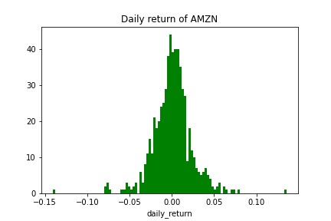

**Figure 8: Daily return of AMZN**

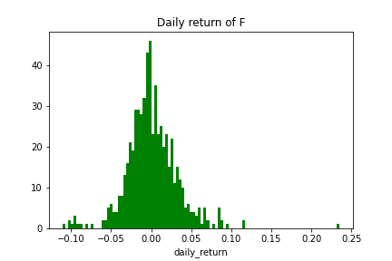

**Figure 9: Daily return of F**

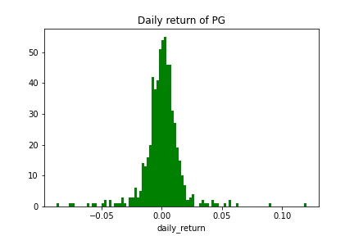

**Figure 10: Daily return of PG**

**\*) Return of a portfolio:**

In case the weights of the [PG, AMZN, AAPL, F] are [0.15,0.2,0.25,0.4] respectively is 0.001033581891293048.

**5. Covariance matrix:**

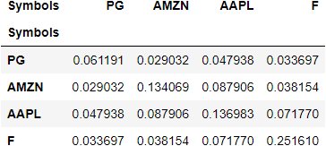

**Table 2: Covariance matric**

As all we see from table 2, the covariances are positive between stocks of 2 companies. It means that the two stocks move in the same direction. When one stock has a positive return, the other tends to have a positive return as well.

**6. The efficient frontier:**

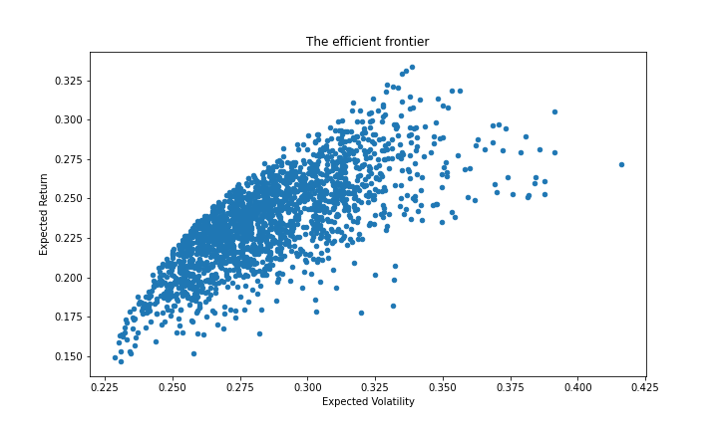

**Figure 11: The efficient frontier**

The figure 11 shows the efficient frontier of the portfolio. Based on the efficient portfolio, the investor can make the decision to invest in a portfolio.

**7. The Sharpe ratio:**

The Sharpe ratio of the portfolio is -0.8019717293013592 that is difficult to evaluate. Therefore, we cannot use this ratio to assess the portfolio.

**8. Predicting stock price with a Monte Carlo Simulation:**

Monte Carlo Simulation method was used to predict the stock prices after 100days since 31/05/2022.

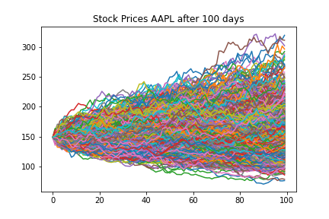

**Figure 12: Stock prices AAPL after 100 days**

The price at day 0 of AAPL was 148.83999633789062 USD, the simulated price at day 100 will gain is 7.458794118163382 USD.

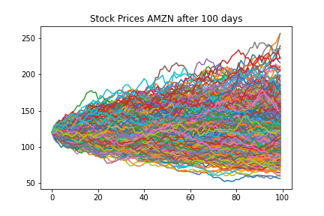

**Figure 13: Stock prices AMZN after 100 days**

The price at day 0 of AMZN was 120.20950317382812 USD, the simulated price at day 100 will gain is 2.3315628527392676 USD.

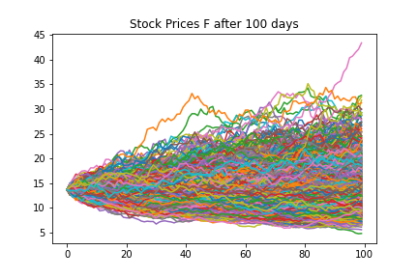

**Figure 14: Stock prices F after 100 days**

The price at day 0 of F was 13.680000305175781 USD, the simulated price at day 100 will gain is 0.47448845305234144 USD.

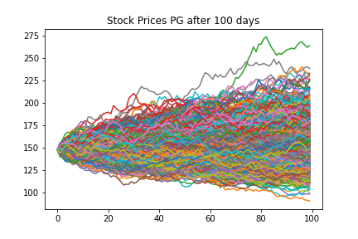

**Figure 15: Stock prices PG after 100 days**

The price at day 0 of PG was 147.8800048828125 USD, the simulated price at day 100 will gain is 2.702965639846127 USD.

In conclusion, after 100 days, both four companies will gain in prices. However, AAPL will gain the highest price and F will gain the least.